|  |
| --- |
| Progress Report / Status Report |

Monthly Report Intern Matteo De Benedetti - October 2019

Approval

|  |  |
| --- | --- |
| Title Monthly Report Intern Matteo De Benedetti - October 2019 | |
| Issue Number 0 | Revision Number 0 |
| Author Matteo De Benedetti | Date 29/10/2019 |
| Approved By | Date of Approval |
|  |  |

Change Log

|  |  |  |  |
| --- | --- | --- | --- |
| Reason for change | Issue Nr. | Revision Number | Date |
| Creation of Document | 1 |  | 29/10/2019 |

Change Record

|  |  |  |  |
| --- | --- | --- | --- |
| Issue Number  0 | Revision Number  0 | | |
| Reason for change | Date | Pages | Paragraph(s) |
| Creation of Document | 29/10/2019 | All | All |
|  |  |  |  |

Distribution

|  |
| --- |
| Name/Organisational Unit |
| Martin Azkarate, TEC-MMA, ESA-ESTEC |
| Mario Innocenti, Robotics and Automation Engineering, University of Pisa |

Table of contents:

1 Introduction 4

1.1 Scope of the Document 4

2 visual odometry performances 4

2.1 Camera Intrinsic and Extrinsic Parameters 4

2.2 Features Matching 6

2.3 Parameters Investigation 7

2.4 Spartan Visual Odometry 9

3 visual odometry tests 11

3.1 Improvements in the Test Setup 11

3.1.1 Initial VO setup: 11

3.1.2 New VO setup 11

3.2 Tests Definition 13

4 Concurrent design facility study 14

4.1 SINPA Study 14

4.2 Robotics 15

4.2.1 Sizing the Robotic Arm 15

4.2.2 Testing of the Sintering Verification Process 15

5 References 16

5.1 Reference Documents 16

5.2 List of Acronyms 16

5.3 Table of Figures 16

# Introduction

## Scope of the Document

This document reports the work done by the author, Matteo De Benedetti, during his second month as an intern in the Planetary Robotics Lab (PRL) at the European Space Research and Technology Centre (ESTEC).

# visual odometry performances

This chapter explains the continuation of the work started in the previous month, where the Viso2 library [RD01, RD02] performances were studied with the objective of trying to improve them.

## Camera Intrinsic and Extrinsic Parameters

In Visual Odometry the objective is to estimate the motion of the camera (and by extension the rover motion if the rover->camera transformation is known) from a set of points in two consecutive frames.

The points are obtained from features detected in the images, which are points in the 2 dimensional image plane, and must be transformed into the 3 dimensional point in the world space, needed for the motion estimation, using the Perspective Stereo Camera Model [RD03, RD04, RD05], as shown in the following figure.

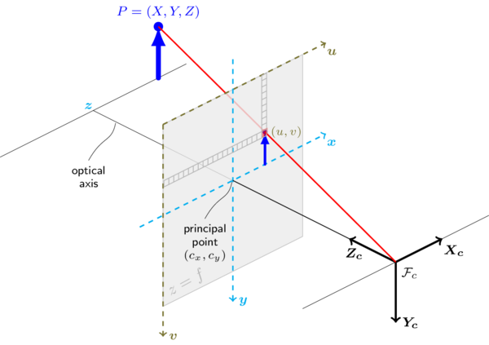

Figure 1: Perspective Camera Model

The model strongly relies on the intrinsic and extrinsic parameters that have to be acquired performing a calibration procedure, which involves moving a chessboard of known parameters in front of the camera, trying to fill the whole field of view with different positions and orientations.

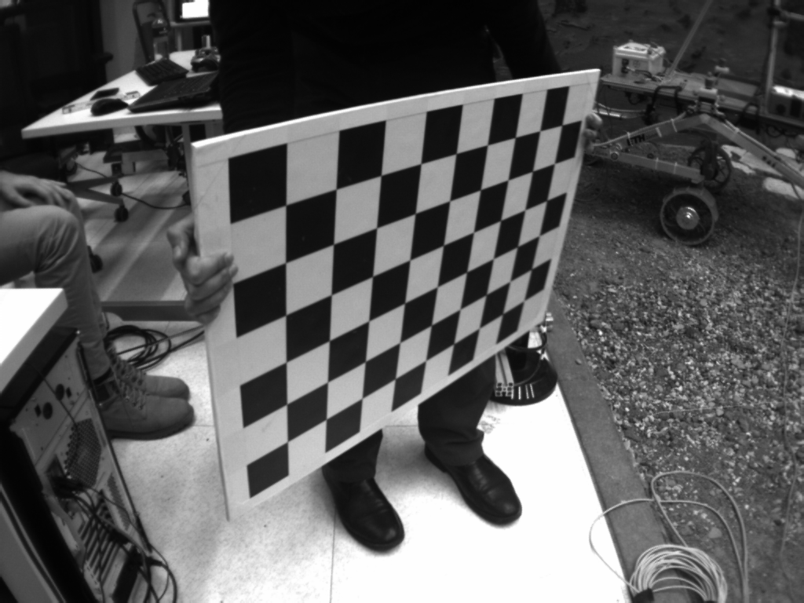

Figure 2: Example of a sample of the calibration process

The parameters were obtained using the Stereo Calibration Package from ROS [RD06] and then were evaluated not only in the effect they have on the Visual Odometry performances, which strongly depends on many other factors, but mostly looking at the disparity frame.

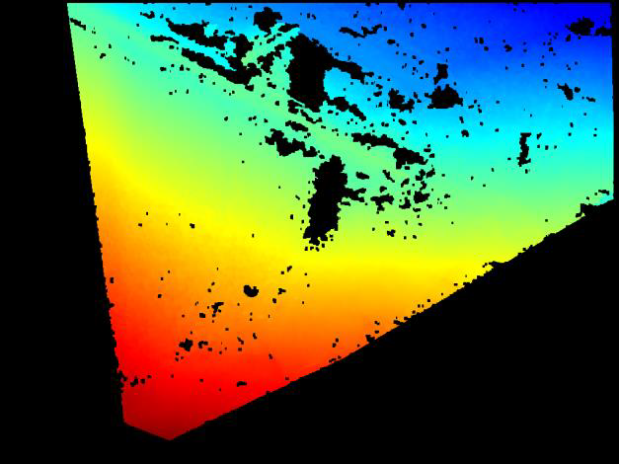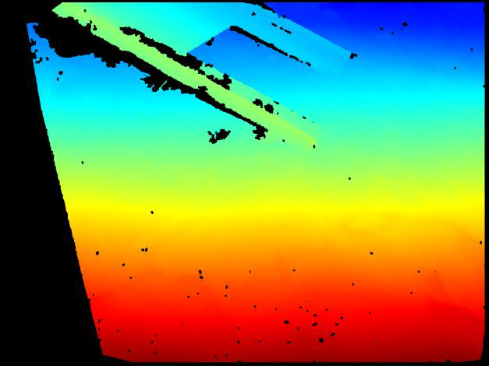

Figure 3: Good (left) and Bad (right) Disparity Frames

The disparity frame on the right shows bad camera calibration since the image is not complete and the object in the top (reconstruction of the ExoMars Deployment Structure) is not well defined. The image on the left instead shows a good set of parameters. The black portion on the left side is expected and results from the composition of two stereo images into a single frame from the perspective of the right camera.

## Features Matching

The features are first detected in both the left and right frame and then matched between the two images, these are called *spatial matches*.

After a second set of stereo frames arrives, the spatial matches are computed again and matched with the ones from the stereo frames at the previous time-step, these are called *temporal matches*.

It was noticed that very few matches were being selected in the bottom part of the image and this can strongly affect the VO performances.

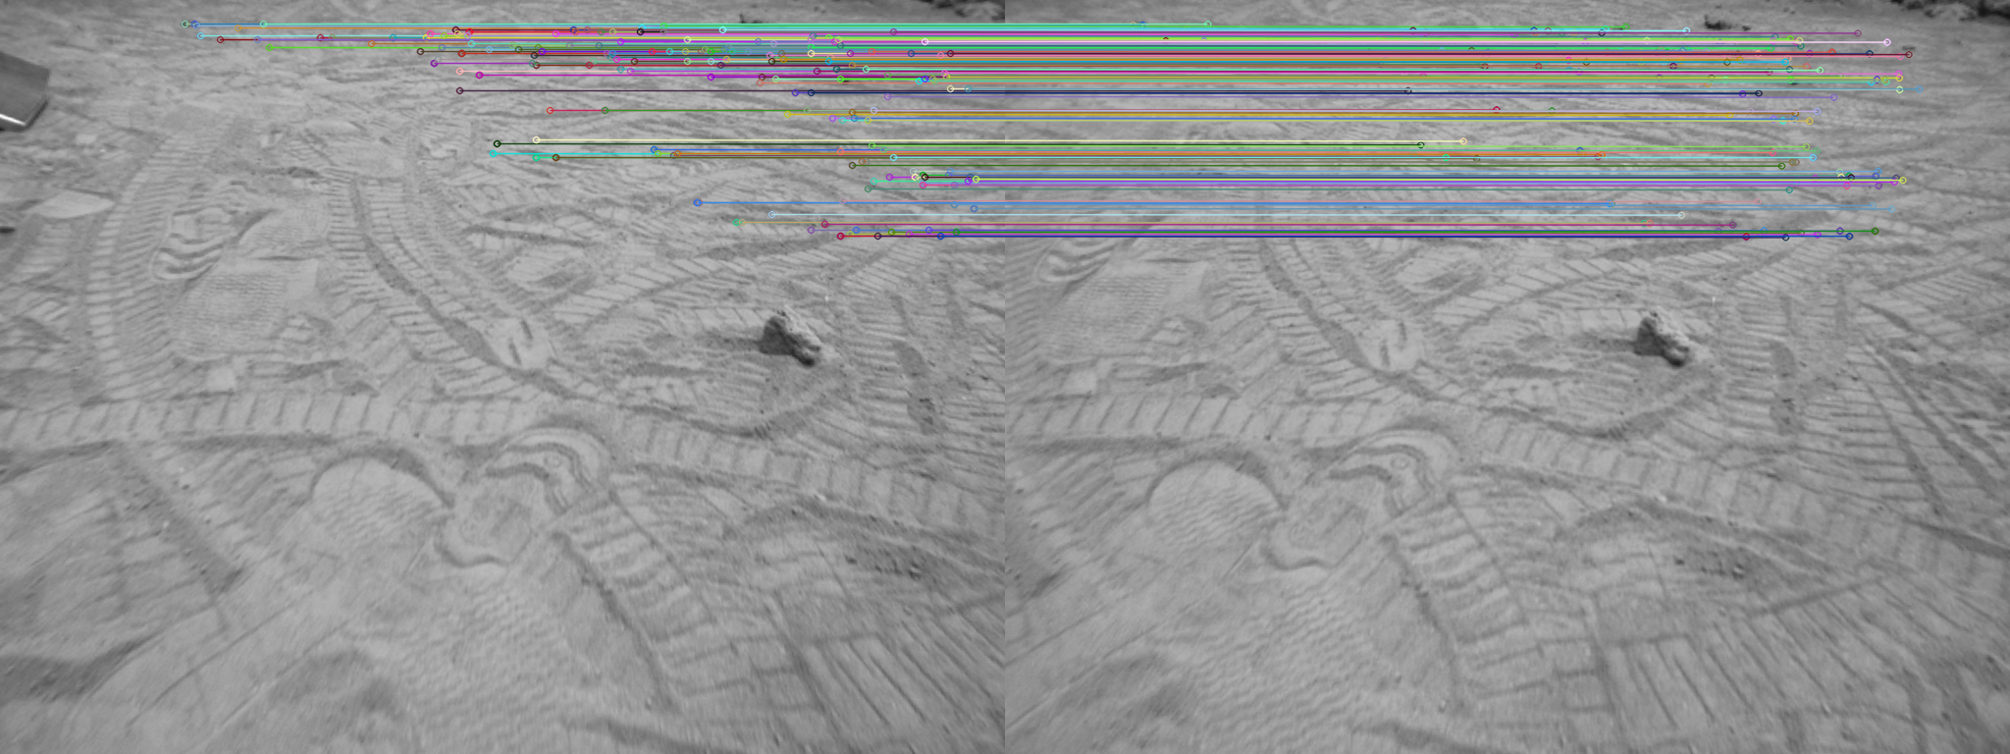

Figure 4: Uneven features distribution

The *Matching Range* parameter of the Viso2 library represents the range (as number of pixels) where a match will be looked for in the other image.

Increasing it to the maximum difference in pixels that can occur between the left and right image led to a significantly better matches distribution.

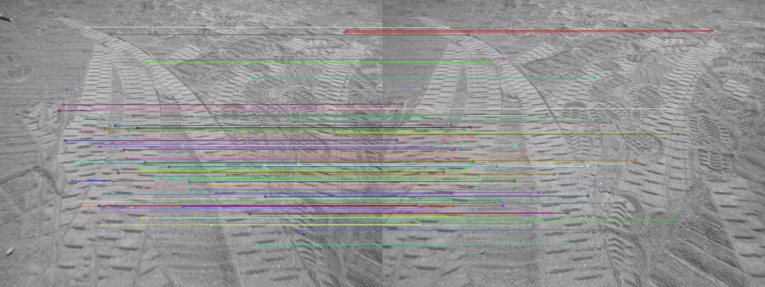

Figure 5: Better features distribution

## Parameters Investigation

The Viso2 library offers many other parameters that can be tuned to obtain better performances.

**Bucketing:**

It is a technique used to spread the feature over the whole image, ensuring that they are not concentrated in a single area, by dividing the frame in a number of sub-areas (buckets) and limiting the maximum number of features that can be extracted from a single bucket.

Bucketing parameters:

* max_features (int, default: 2)

maximum number of features per bucket.

* bucket_width (double, default: 50.0)

width of the bucket (in pixels).

* bucket_height (double, default: 50.0)

height of the bucket (in pixels).

**Matching:**

These parameters affect the way matches are assigned between sets of features, the one that was found having the most impact was the match radius which, as explained in the previous section, helped obtaining matches in the lower part of the image, where the difference in pixel between the left and right frame is bigger.

Matcher parameters:

* nms_n (int, default: 3)

minimum distance between maxima in pixels for non-maxima-suppression.

* nms_tau (int, default: 50)

interest point peakiness threshold.

* match_binsize (int, default: 50)

matching width/height (affects efficiency only)

* match_radius (int, default: 200)

matching radius (in pixels)

* match_disp_tolerance (int, default: 2)

vertical tolerance for stereo matches (in pixels).

* outlier_disp_tolerance (int, default: 5)

disparity tolerance for outlier removal (in pixels).

* outlier_flow_tolerance (int, default: 5)

flow tolerance for outlier removal (in pixels).

* multi_stage (int, default: 1)

0=disabled, 1=multistage matching (denser and faster).

* half_resolution (int, default: 1)

0=disabled, 1=match at half resolution, refine at full resolution.

* refinement (int, default: 1)

0=none, 1=pixel, 2=subpixel.

**Outlier Removal:**

The matches are usually affected by a number of outliers and it is really important to reject as much as possible to obtain an accurate estimation.

The algorithm used in Viso2 is RANSAC [RD04], RANdom SAmple Consensus, an iterative method which uses a model of the problem, in this case the estimated motion, to find the best subset of samples, in this case the matches, that validates the model.

RANSAC parameters:

* ransac_iters (int, default: 200)

number of RANSAC iterations.

* inlier_threshold (double, default: 1.5)

fundamental matrix inlier threshold.

* reweighting (bool, default: true)

lower border weights (more robust to calibration errors).

Initially individual parameters or small batches of them were modified, to get an idea of how they worked and what is the effect on the VO performances.

Then 3 main sets of VO parameters were created and they were tested alongside with 2 intrinsic/extrinsic parameters set for the camera, 2 body->camera transformation and the IMU disabled or enabled.

|  |
| --- |
| VO Parameters |
| VO set 1 |
| VO set 2 |
| VO set 3 |
| Camera Parameters |
| Camera set 1 |
| Camera set 2 |
| Body-Camera Transformation |
| Transform 1 |
| Transform 2 |
| IMU |
| Used |
| Not used |

The combination of all the previous parameters led to 24 tests. The best set of VO, camera and transform parameters achieved the following results, compared to the performance of the original implementation of the Viso2 VO:

* XY error norm: 0.168 [m] after a travelled distance of 5 [m], meaning a 3.35% error
* Heading error: 1.998 [deg]

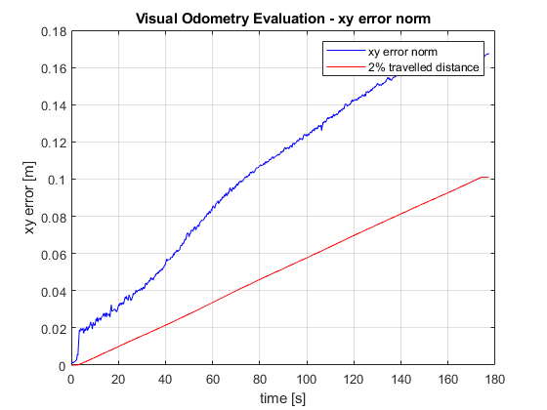

Figure 6: Viso2 xy error norm

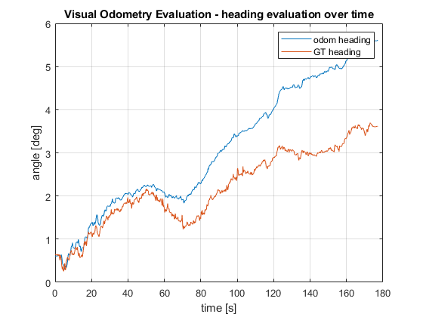

Figure 7: Viso2 heading error

## Spartan Visual Odometry

In the meantime a colleague of the PRL was working on the SPARTAN VO library [RD07], trying to improve its performances.

We worked together during the recalibration of the camera and the new parameters greatly improved its performance, achieving better results than Viso2:

* XY error norm: 0.0508 [m] after a travelled distance of 5 [m], meaning a 1.02% error
* Heading error: 0.021 [deg]

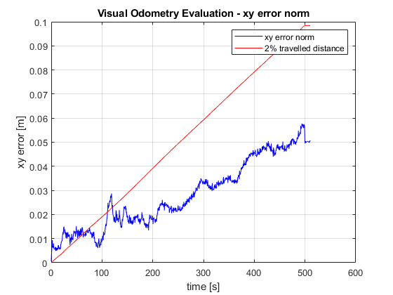

Figure 8: SPARTAN VO xy error norm

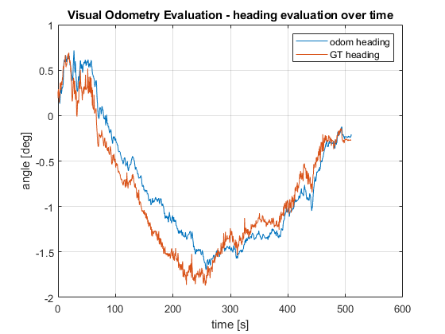

Figure 9: SPARTAN VO heading error

# visual odometry tests

Considering the better performances achieved by the SPARTAN VO it was decided to proceed with it for the testing.

Before start working on the tests it was necessary to make it fully compatible with the ROcK framework on the ExoTer Rover.

## Improvements in the Test Setup

The large amount of experiments conducted while testing all the parameters showed the necessity to create a better, faster and more flexible way of controlling the rover and running the tests.

### Initial VO setup:

At the beginning the VO was executed controlling the rover movement with a joystick, which is acceptable for short distances and if the exact motion is not important.

The visodom.rb [RD01] diagram works as explained in the picture below.

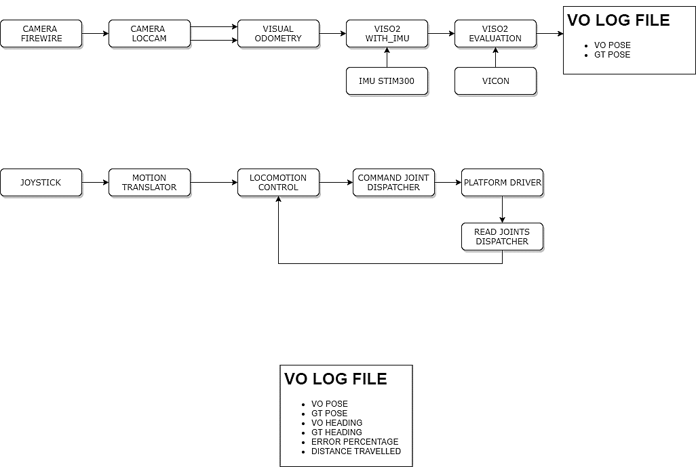

Figure 10: vidom.rb tasks diagram

### New VO setup

A new pipeline has been developed, focusing on completely removing the use of the joystick and making the visual Odometry script as light as possible, making the VO the only task that is running live, while the IMU, Vicon, motion commands and camera frames are provided by a log file, instead of being acquired in real time while the rover moves.

To achieve this two new scripts and a new ROcK component have been created [RD01]:

* Virtual_visodom.rb
* Vo_test_gen.rb
* Motion_generator

This approach improved consistency across all the tests (the trajectory and the camera frames are exactly the same across all the tests), strongly reduced the time needed for the each run and removed the need to have access to the rover itself.

**VIRTUAL_VISODOM.RB**

This script runs the VO without the need of any live external signals (camera frames, Vicon, IMU and motion commands) but only uses the provided log files.

Also a similar script has been created for the SPARTAN VO.

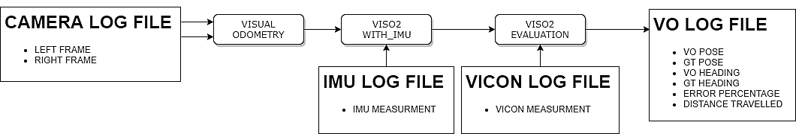

Figure 11: virtual_visodom.rb tasks diagram

**VO_TEST_GEN.RB:**

This script generates the necessary log files to run the virtual_visodom.rb script

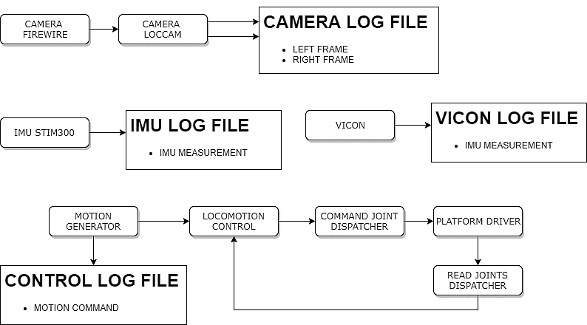

Figure 12: vo_test_gen.rb tasks diagram

**MOTION_GENERATOR COMPONENT:**

This component is used in the vo_gen_test.rb and replaces the joystick and motion_translator tasks, generating a sequence of control signals at a specific time, to autonomously drive the rover.

## Tests Definition

A preliminary idea for the tests is to study how the VO performs in the following conditions:

* Velocity (both translational and rotational)
* Trajectory (straight path, point turn, Ackermann turn, complex trajectory)
* Light conditions
* Camera position and orientation
* Terrain type (sand, sand with small rocks, small rocks, big rocks)

The first objective is to start studying the behaviour of the Spartan VO at different velocities.

Velocity has an effect on many other factors like the *overlap percentage* between two frames (which can be also influenced by the *frequency* that the VO runs at) the *blurriness* of the image (which can be mitigated decreasing the *exposure time*, at the cost of reduced *image brightness*, which also depends on the *ambient light*).

In summary, the parameters that will be initially studied and varied, to better understand the effect they have on VO performances and also how they affect each other, are:

* Translational speed of the rover
* VO frequency
* Exposure time
* Ambient light

A first set of tests has been defined with the objective of trying to find the effect of only the translational velocity on the VO performances.

After this a new set of tests will be performed fixing the velocity and changing the VO frequency, with the objective of varying the image overlap percentage, and see if and how it affects the VO performances.

**Image Overlap Calculator:**

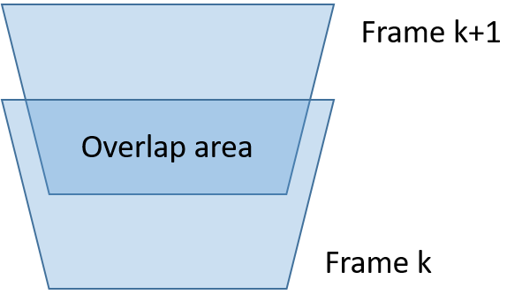

To estimate the overlap percentage between two frames, a function has been defined which, given the camera height and pitch, VO frequency, rover speed and both horizontal and vertical FoV, outputs an overlap percentage.

# Concurrent design facility study

The Concurrent Design Facility (CDF) is a state-of-the-art facility equipped with a network of computers, multimedia devices and software tools, which allows a team of experts from several disciplines to apply the concurrent engineering method to the design of future space missions. It facilitates a fast and effective interaction of all disciplines involved, ensuring consistent and high-quality results in a much shorter time.

It is primarily used to assess the technical and financial feasibility of future space missions and new spacecraft concepts (e.g. internal pre-phase A or Level-0 assessment studies) providing:

* new mission concept assessment
* space system trade-offs and options evaluation
* new technology validation at system/mission level

ESA defines Concurrent Engineering as: "a systematic approach to integrated product development that emphasises the response to customer expectations. It embodies team values of co-operation, trust and sharing in such a manner that decision making is by consensus, involving all perspectives in parallel, from the beginning of the product life-cycle."

Essentially, CE provides a collaborative, co-operative, collective and simultaneous engineering working environment.

This is achieved thanks to the infrastructure itself but also using the OCDT (Open Concurrent Design Engineering Tool), a Microsoft Excel add-on that allows a parallel development across all the subsystem using a server-based system where all the users are able to share data with a push/pull scheme (conceptually similar to the Version Control Systems commonly used in software development).

## SINPA Study

The SINtering PAyload study I joined is a preliminary study for a lunar mission to test the lunar regolith sintering process.

I was part of the Robotics team along with 2 colleagues, and we worked in coordination with the Systems, Optics, Thermal, Power, Operations, Configurations and Cost Teams in addition to experts from ESAC (European Space Astronomy Centre in Madrid, Spain) and the industry.

The objectives of the study are to:

* Explore the identified payload options for lunar regolith sintering:
  + Solar sintering with mirror
  + Solar sintering with lens
  + Microwave sintering
* Define, for each option, a payload concept of operations
* Derive a preliminary system design for the payload and the carrying platform (rover or static);
* Identify technology gaps

The mission is based on a Lunar Lander, but the objective of the study was not to design the lander, which has been picked from commercially available options, but instead to design a payload that is able to:

* Sinter a 10x10cm patch of lunar regolith
* Verify the outcome of the sintering process

## Robotics

In the Robotics Team I joined 4 sessions and took care of the data in the OCDT system.  
The whole team faced 4 main tasks;

* Decide if a rover or a robotic arm should have been used
* Size the Robotic Arm (motors and limbs)
* Size the Pan and Tilt Unit for the Lens Payload option
* Test the sintered sample verification process

### Sizing the Robotic Arm

To choose the Motors and design the Links of the Robotic Arm the worst case scenario in terms of torques was considered, which is the arm in a fully extended position, parallel to the ground.

The motors have been picked from the Delian Project [RD08], a family of Robotic Arm motors designed for an ESA study, with the advantage of having a high TRL.

The Limbs were designed taking in mind the bending moment that the end effector, joints and structure generates.

### Testing of the Sintering Verification Process

The method to verify the sinter is to apply pressure on the sintered sample.

The Materials Division provided samples of a lunar soil replica and sintered samples that were pressed until they broke with an indenter with a force/torque sensor.

These experiments showed that it is possible, from the readings of the F/T sensor, to discern the sample from the soil, even if it is slightly buried, and then evaluate the sintering process.

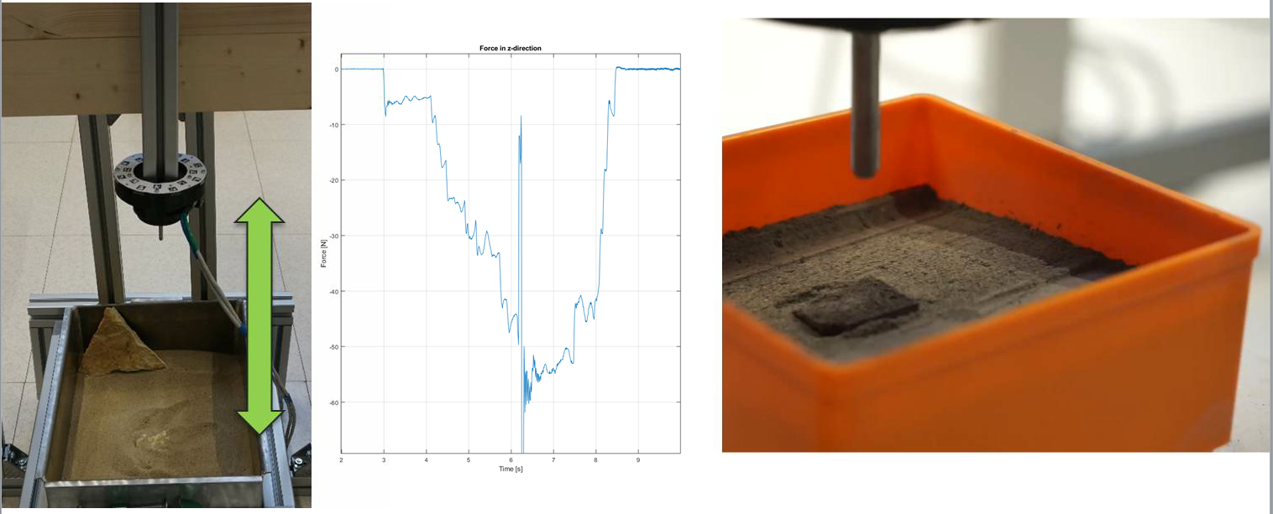

Figure 13: Test Setup of the sintering verification process

# References

## Reference Documents

|  |  |
| --- | --- |
| Reference | Document |
| [RD01] | ESA PRL GitHub, visodom branch, https://github.com/esa-prl/ |
| [RD02] | Personal GitHub, https://github.com/MatteoDeBenedetti/ESA-Thesis |
| [RD03] | “Visual Odometry: Part I - The First 30 Years and Fundamentals”, Davide Scaramuzza, Friedrich Fraundorfer​ |
| [RD04] | “Visual Odometry: Part II –Matching, Robustness, Optimization, and Applications”, Davide Scaramuzza, Friedrich Fraundorfer |
| [RD05] | Viso2 Library, “Visual Odometry based on Stereo Image Sequences with RANSAC-based Outlier Rejection Scheme”, Bernd Kitt and Andreas Geiger and Henning Lategahn |
| [RD06] | Stereo Calibration Package http://wiki.ros.org/camera_calibration/Tutorials/StereoCalibration |
| [RD07] | “SPARTAN: Vision-based Autonomous Navigation System for fast traversal planetary Rovers” Avilés, Marcos & Lourakis, Manolis & Lentaris, George & Zabulis, Xenophon & Stamoulias, Ioannis & Maragos, Konstantinos & Mora, Dario & Soudris, Dimitrios. (2018). |
| [RD08] | “Dextrous Lightweight Arm for Exploration (DELIAN)” A. Rusconi et al., ASTRA 2015 |

## List of Acronyms

|  |  |
| --- | --- |
| Acronym | Full description |
| ESA | European Space Agency |
| ESTEC | European Space Research and Technology Centre |
| VO | Visual Odometry |
| PRL | Planetary Robotics Laboratory |
| ROCK | Robot Construction Kit framework |
| ExoTer | ExoMars Testing Rover |
| RANSAC | RANdom Sample Consensus |
| CDF | Concurrent Design Facility |
| OCDT | Open Concurrent Design Tool |
| PTU | Pan and Tilt Unit |
| F/T Sensor | Force and Torque Sensor |

## Table of Figures

Figure 1: Perspective Camera Model 4

Figure 2: Example of a sample of the calibration process 5

Figure 3: Good (left) and Bad (right) Disparity Frames 5

Figure 4: Uneven features distribution 6

Figure 5: Better features distribution 6

Figure 6: Viso2 xy error norm 9

Figure 7: Viso2 heading error 9

Figure 8: SPARTAN VO xy error norm 10

Figure 9: SPARTAN VO heading error 10

Figure 10: vidom.rb tasks diagram 11

Figure 11: virtual_visodom.rb tasks diagram 12

Figure 12: vo_test_gen.rb tasks diagram 12

Figure 13: Test Setup of the sintering verification process 15